

**American International University- Bangladesh**

**CSC 3215: Web Technologies**

**CO2 and CO4 Evaluation**

**Finished Project Report**

**Fall 2020-2021**

**Project Title: Vital Infusion - HOUSE AND MEDICAL SERVICE MANAGEMENT**.

**Section:** E

|  |  |
| --- | --- |
| Student Name | Student Id |
| Tanjim Mahmud Rakin | 19-41424-3 |
| Mabin Noor Rashid | 17-35941-3 |
| Nafinur Leo | 20-42195-1 |
| MD Ashraful Amin Sakib | 20-42940-1 |

**Project Description:**

In this busy era, we always look for a helping hand for our household chores. Sometimes, it becomes essential to find a helping hand. Same for medical services. So, we decided to work on these, so that users can find desired household help and required medical service at the same place.

**House-hold Helpers:**

Our project will help people to find house hold helpers like maid, electricians and mechanics all under one platform without any hesitation. This will create job opportunities for a lot of unemployed people. Also this will help both users and the house hold helpers. User can manually set timings and work descriptions for the helpers, thus the bill will be based on the helper’s work.

**Medical Services**:

We often need emergency medical services like ambulances and oxygen cylinders. But due to lack of service opportunities we found it hard to find an exact place to order these essential medical services. So to solve this problem we have introduced the feature of emergency medical services. Where user can order ambulance, oxygen or even medicines 24/7 from our platform.

In our website there will be total four roles user, service-seller, vendor and admin. User can order products from vendors and take services from the service sellers. Likewise, service sellers can offer their service and vendors can sell medical products. Admin can approve vendors and service sellers.

All four roles can sign up(create), log in, edit and delete their information.

**Project Folder Structure:**

Model:

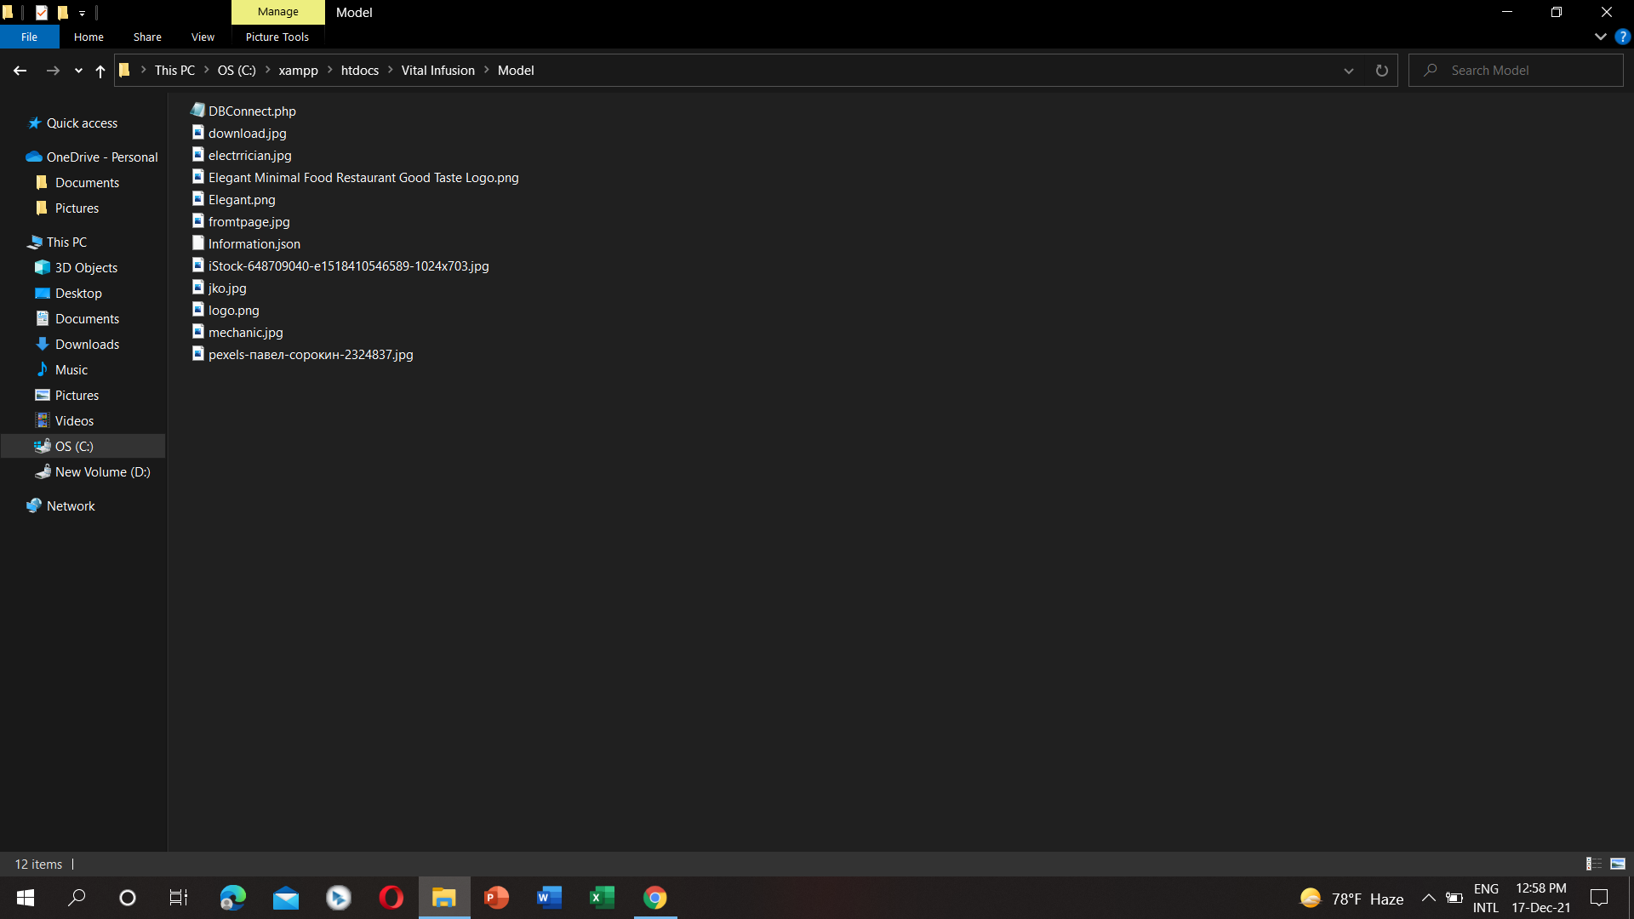

Controller:

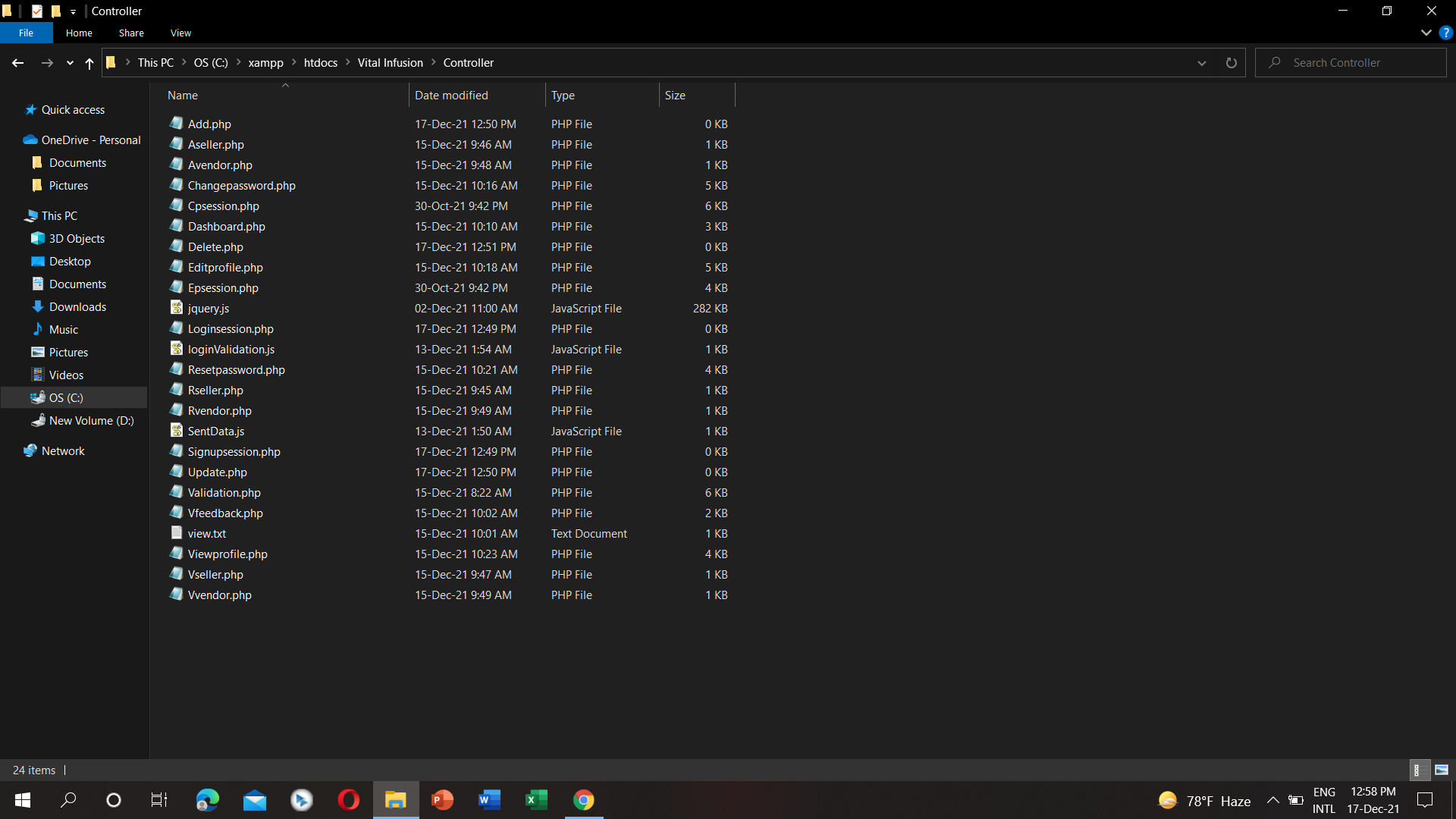

**View:**

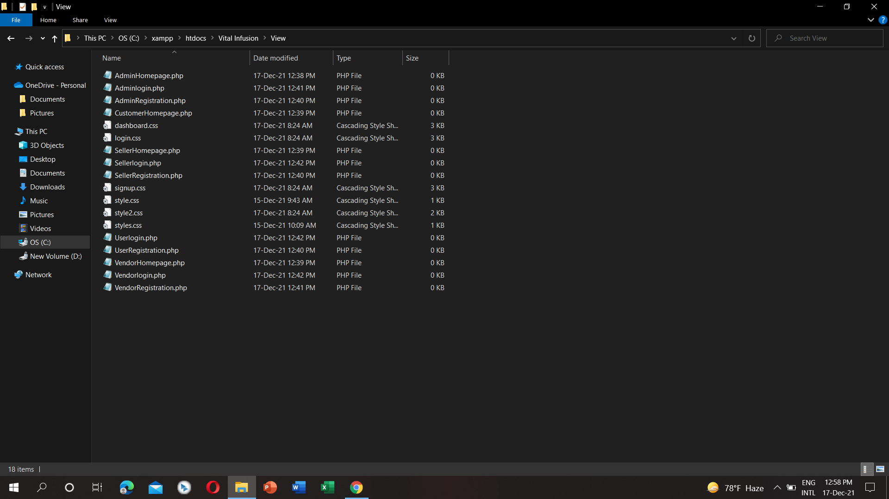

**Core Modules of the Project:**

***User-signup.php***

<!DOCTYPE html>

<html>

<head>

<meta charset="utf-8">

<title>SignUp - Vital Infusion</title>

<link rel="stylesheet" href="css/signup.css">

<link rel="shortcut icon" href="images/logo.png" type="image/x-icon">

</head>

<body style="background-color:#7CB9E8;">

<nav>

<div class="logo">

<div>

<img class="logo-image" src="images/logo.png" alt="">

</div>

<h2 class="logo-name">Vital Infusion</h2>

</div>

<ul>

<li><a href="Homepage.php">Home</a></li>

<li><a href="Login.php">Login</a></li>

<li><a href="Signup.php">Signup</a></li>

</ul>

</nav>

<?php

include 'Controller/valid.php';

?>

<br></br>

<div class="signup-form">

<h1>SIGN UP</u></h1><br><br>

<img src="images/logo.png" alt="" height="100px" style="position:absolute; top: 30px;">

<form method="POST" action="<?php echo htmlspecialchars($_SERVER["PHP_SELF"]); ?>" enctype="multipart/form-data">

<div class="inputs-container">

<div>

<label ><b>Enter Your Name:</b>&nbsp;</label><br>

<input class="input-field" type="text" id="name" name="name" placeholder="Your Name" size="10" value="<?php echo $name;?>">

<?php

if ($nameErr != "")

{

echo "* ";

echo $nameErr;

}

?>

</div>

<div>

<label ><b>Enter Phone Number</b>&nbsp;</label><br>

<input class="input-field" type="numeric" id="pn" name="pn" placeholder="Phone Number" size="11" value="<?php echo $pn;?>">

<?php

if ($pnErr != "")

{

echo "* ";

echo $pnErr;

}

?>

</div>

<div>

<label><b>Enter Your Email</b>&nbsp; </label><br>

<input class="input-field" type="text" id="email" name="email" value="<?php echo $email;?>" placeholder="someone@example.com">

<?php if ($emailErr != "")

{

echo "*";

echo $emailErr;

}

?>

</div>

<div>

<label><b>Enter User Name</b></label><br>

<input class="input-field" type="text" name = "un" value="<?php echo $un;?>"placeholder="Your username">

<?php if ($unErr != "")

{

echo "*";

echo $unErr;

}

?>

</div>

<div>

<label><b>Enter Password</b></label><br>

<input class="input-field" type="password" name = "pass" value="<?php echo $pass;?>" placeholder="Password" >

<?php if ($passErr != "")

{

echo "*";

echo $passErr;

}

?>

</div>

<div>

<label><b>Re-enter Password</b></label><br>

<input class="input-field" type="password" name = "Cpass" value="<?php echo $Cpass;?>"placeholder="confirm Password">

<?php if ($CpassErr != "")

{

echo "*";

echo $CpassErr;

}

?>

</div>

<div>

<label><b>Enter Your Gender</b>&nbsp;</label><br>

<div style="margin-top: 10px">

<input type="radio" id="gender" name="gender"<?php if (isset($gender) && $gender=="Male") echo "checked";?> value="Male">

<label for="">Male</label>

<input type="radio" id="gender" name="gender"<?php if (isset($gender) && $gender=="female") echo "checked";?> value="female">

<label for=" ">Female</label>

<input type="radio" id="gender" name="gender"<?php if (isset($gender) && $gender=="other") echo "checked";?> value="other">

<label for="">Other</label>

<?php

if($genderErr)

{

echo "* ";

echo $genderErr;

}

?>

</div>

</div>

<div>

<label><b>Date of Birth</b>&nbsp;</label><br>

<input class="input-field" type="date" name="dob" value="<?php echo $dob;?>">

<?php

if($dobErr)

{

echo "* ";

echo $dobErr;

}

?>

</div>

<div>

<label><b>Enter Profile Picture</b>&nbsp;</label>

<input style="margin: 5px" type="file" name="fileToUpload" id="fileToUpload">

<img src="<?php if(!empty($filepath)){echo $filepath;}else{ echo "images/default.jpg";} ?>" alt="" width="100px" height="100px"><br></br>

<?php

if ($ImgErr) {

echo ($ImgErr);

}

?>

</div>

</div>

<div class="button-container">

<input class="submit-button" type="submit" value="Submit">

</div>

<p class="text-button">Already Have An Account? <a href="Login.php">Login Now.</a></p>

<?php

if (isset($insertion))

{

echo "<span style='color:brown'><b>" . $insertion . "</b></span><br>";

}

?>

</form>

<br>

</div>

</body>

</html>

***User-order.php***

<?php

$servername="localhost";

$username="root";

$password="";

$dbname="vital infusion";

$conn=new mysqli($servername,$username,$password,$dbname);

if(isset($_POST['submit'])){

if(!empty($_POST['order']) && !empty($_POST['details'])){

$order = $_POST['order'];

$details = $_POST['details'];

$s = "INSERT INTO user_order(no, details) VALUES('$order', '$details')";

$q = mysqli_query($conn,$s) or die (mysqli_error());

if($q){

echo "Inserted";

}

else{

echo "Not Inserted";

}

}

}

?>

<html>

<head>

<title>Order</title>

<link rel="stylesheet" href="css/login.css">

<link rel="shortcut icon" href="images/logo.png" type="image/x-icon">

</head>

<body style="background-color:#7CB9E8;">

<nav>

<div class="logo">

<div>

<img class="logo-image" src="images/logo.png" alt="">

</div>

<h2 class="logo-name">Vital Infusion</h2>

</div>

<ul>

<li><a href="Homepage.php">Home</a></li>

<li><a href="Login.php">Login</a></li>

<li><a href="Signup.php">Signup</a></li>

</ul>

</nav>

<div class="login-form">

<h1>Order Place</h1>

<form id="form" class="form" >

<div class="form-control">

<label for="username"><strong>Order Id:</strong></label>

<input class="input-field" type="text" placeholder="111" id="order" name = "order"/>

<i class="fas fa-check-circle"></i>

<i class="fas fa-exclamation-circle"></i>

<small></small>

</div>

<div class="form-control" style="margin-top: 7px">

<label for="username"><strong>Details:</strong></label>

<input class="input-field" type="text" placeholder="title with contact" id="details" name = "details"/>

<i class="fas fa-check-circle"></i>

<i class="fas fa-exclamation-circle"></i>

<small></small>

</div>

<div class="button-container">

<input class="submit-button" type="submit" value="Submit">

<button class="submit-button" type="button" onclick="window.location.href = 'Dboard.php';">Back</button>

</div>

</div>

</form>

<script src='jav.js'></script>

</body>

</html>

***Admin-dashboard.php***

<!DOCTYPE html>

<html>

<head>

<meta charset="utf-8">

<title>Dashboard</title>

<link rel="stylesheet" href="styles.css">

</head>

<body style="background-color:#add8e6;">

<?php

session_start();

$isset=false;

if(isset($_SESSION['un']))

{

$current = file_get_contents("Model/Information.json");

$current = json_decode($current, true);

foreach($current as $key=>$value){

if($value['Username']==$_SESSION["un"])

{

$Name=$value['Name'];

$Gender=$value['Gender'];

$Username=$value['Username'];

$DOB=$value['DOB'];

$isset=true;

break;

}

}

if($isset){

$Confirm_msg="";

}else{

$Errmsg="Something did not match";

}

}

?>

<navbar class="menu-bar" style="float: right;">

<span>

<a href="Homepage.php" style="color:indianred;" > Home </a>

<span>&nbsp;|&nbsp;</span>

<span>&nbsp;</span>

<a href="Login.php" style="color:indianred;" class="option">Login</a>

<span>&nbsp;|&nbsp;</span>

<span>&nbsp;</span>

<a href="Signup.php" style="color:indianred;" class="option">Signup</a>

</navbar>

<br>

<div class="intro">

<br>

<?php

echo "Logged in as ".$Name;

?>

<br>

</div>

<div class="container">

<img src="Picture/jko.jpg" alt="Cinque Terre" width="1000" height="300">

<div class="center">

<table border=1 style="width:800px; border-style: none;border-collapse: collapse;">

<tr>

<td style="width:250px">

<legend>Account<hr></legend>

<ul >

<li><a href="Dashboard.php">Dashboard</a></li>

<li><a href="Viewprofile.php">View Profile</a></li>

<li><a href="Editprofile.php">Edit Profile</a></li>

<li><a href="Changepassword.php">Change Password</a></li>

<li><a href="Login.php">Log out</a></li>

<li><a href="Aseller.php">Add Seller</a></li>

<li><a href="Rseller.php">Remove Seller</a></li>

<li><a href="Vseller.php">Verify Seller</a></li>

<li><a href="Avendor.php">Add Vendor</a></li>

<li><a href="Rvendor.php">Remove Vendor</a></li>

<li><a href="Vvendor.php">Verify Vendor</a></li>

<li><a href="Vfeedback.php">View Feedback</a></li>

</ul>

</td>

<td style="width:550px; vertical-align:top;">

<br> </br>

&nbsp; &nbsp;

<?php

echo " <b> Welcome , ".$Name."<b>";

?>

</td>

</tr>

</table>

</div>

</div>

<div class="foot">

<p> <b>Date: <?php echo date("Y/m/d") ; ?></b></p>

</div>

</body>

</html>